
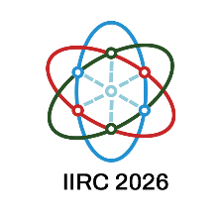

Insight International Research Conference 2026 (IIRC2026)
on
“Trends in Sustainable Technology: Opportunities and Challenges”

DECLARATION BY AUTHOR(S)

- I / We the undersigned declare that the abstract titled ……………………………………

………………………………………………………………………………………………………….
has not been presented or published elsewhere in the current form.
- I / We further confirm that the abstract includes work done by me / all of us and I / We have read the abstract.
- I / We also confirm that this abstract is devoid of any plagiarism, self-plagiarism or use of AI in developing this abstract.
- Further, I / We declare that I / We have not omitted any other person who was involved in this study.
- I / We also agreed collectively on the order of the authorship.
- On behalf of me / us, the corresponding author will communicate with the conference organizers.
- I / We also agree that one of the authors will take the responsibility of presenting the paper at the Conference.

 | Name | Signature | Date
Author 1

Author 2

Author 3

Author 4

Add more rows, if required.

Note: Email the completed declaration form to secretary-iirc@insight.edu.lk once you submit the paper via the conference management system. The submission will not be processed until we receive the declaration form.

